Coalition of Gurdwaras of California
Spokespersons: Raminder Singh Sekhon and Dr. Baljit S. Sahi

News published in:
- India Journal, Santa Fe Springs, Ca June 24th, 2005. pages28-31
- IndiaPost, Union City,Ca. July Ist, 2005. Pages 26-29

Pashaura Singh Turns His Back to Sri Akal Takhat
Sikhs Appeal to Jathedar

To prove that Kachi Bani is not different from the Sachi/Pakki Bani of Adi Sri Gurū Granth Sahib, revisions in Mul Mantar and the creation of doubts on the revelatory character of Bani as enshrined in Guru Granth Sahib have become the fastest growing epidemic in the western universities. It was due to such ridiculous and wrong interpretations of Bani by using unauthentic sources; Dr. Pashaura Singh’s Ph.D. thesis caused a strong reaction from Sikh researchers and intellectuals all over the world because of the poor quality of research and misrepresentation of the Sikh history & Sikh Scripture merely on conjectural basis and unauthentic documents. Sri Akal Takhat, the highest Sikh religious and temporal authority at Amritsar also took notice of this based on the report of Sikh Academia. They called Dr. Pashaura Singh to explain the blasphemous statements in his thesis and gave him a list of academic charges in writing. He presented himself before the five high priests and apologized for the wrongdoings he had done. He admitted the wrongdoings in his Research in written& accepted the Punishment. He was Indicted & Declared Tankhaiya (guilty) by Akal Takhat at Amritsar India for his blasphemous writing against the Sikh religion--the 5th largest among the world religions. The details of the issue were published in the journal, “Abstract of Sikh Studies” Jully 1994 issue as follows:

AKAL TAKHT INDICTS PASHAURA SINGH
Amritsar, June 27, 1994

In a historic judgement delivered by Professor Manjit Singh, Jathedar of Sri Akal Takht, the highest spiritual and temporal authority/ seat of Sikhs, Pashaura Singh was declared guilty of five charges of blasphemy. Pashaura Singh had made a number of baseless observations in his Ph.D. thesis, "The Text and Meaning of the Adi Granth", submitted to the University of Toronto in 1991, to please his supervisor who is well known as an adversary of Sikhism and with an eye on a university job. The unanimous verdict followed a detailed hearing of Pashaura Singh's case in an 8 hour non-stop session of the Five High Priests presided over by Prof Manjit Singh at the Akal Takht Sahib on the 25th June 1994. '

The judgment says that Pashaura Singh had attacked the authenticity of Sri Guru Granth Sahib, which had deeply hurt the sentiments of the Panth: He had also levelled baseless charges against the Fourth and the Fifth Masters, saying that they had made alterations in the Mul Mantra as well as linguistic and theological changes in the bani of Guru Nanak.

The tankhah (religious punishment) awarded to Pashaura Singh for the offences committed by him, includes dusting of shoes of the sangat, washing of the parkarma of Sri Harmandir Sahib, besides listening to kirtan and reciting of Japuji Sahib, over a period of five weeks. At the completion of this penance he has been directed to appear before the sangat at the local gurdwara in Michigan, where he resides, and request the granthi to pray for his forgiveness. It may still be necessary for him to finally appear before the Akal Takht for forgiveness as is the normal procedure in such matters.
It may be recalled that Pashaura Singh's thesis had attracted sharp criticism from scholars, and incurred indignation and condemnation of the masses for its blasphemous formulations. SGPC, the highest elected religious body of the Sikhs, took cognizance of the offence, and after a thorough scrutiny by two Expert Committees of scholars, referred the matter to Sri Akal Takht Sahib for appropriate action.
The judgement which is reproduced, also directs Pashaura Singh not to publish his thesis in the present form. During the hearing Pashaura Singh submitted a confessional statement in which he pleaded guilty to all charges, and undertook to revise his thesis as well as his previous publications in the light of the findings of the present inquiry. We are also reproducing the five charges read out to Pashaura Singh, to which he pleaded guilty. In fact, these represent only a sample of the blasphemous contents of his thesis.
Ik Onkar Waheguru ji ki Fateh SRI AKAL TAKHT SAHIB
No...../217/ /94 Hukmnama Sri Amritsar 27/6/94
Dr Pashaura Singh,
On summons from Sri Akal Takht Sahib you presented yourself before the Takht on the 25th June, 1994 in connection with your controversial thesis "The Text and Meaning of the Adi Granth". After prolonged deliberations in the sacred congregation of Sikh scholars, you have pleaded guilty in writing to the five charges of misrepresentations levelled against you. In this connection you have also pledged to bow your head before every decision of the Takht.

The views expressed in your thesis have caused intense hurt to the sentiments of Sikhs who accept Sri Guru Granth Sahib as their Living Guru. This has been demonstrated by Sikhs in India and abroad through a large number of letters, messages and books, received in the Akal Takht Sahib during the last two years. Such pious sentiments of love towards the Guru, on the part of the Sikh Sangat, have always found expression through the Akal Takht Sahib.

As a Sikh scholar, you were expected to produce literature to promote the welfare of all, with commitment to Sri Guru Granth Sahib and the Guru Panth. But what happened was exactly the opposite of this. Taking cognizance of the overall situation in the Panth, Sri Akal Takht is pleased to issue the following orders for your compliance:-
1) You shall not publish this controversial thesis in the present form, nor shall you authorize anyone else to publish it.
2) The charges and the objections relating to doctrines or presentation, raised by Sikh scholars against this thesis, have been pointed out, and accepted by you. Some of these have been given to you in writing. These shall be removed by you in letter and spirit from the thesis. And in case the thesis is to be published in the future, it will be done according to Gurmat with full regard for the sentiments of the Sikh community.
3 ) In deference to the sentiments of the Guru Panth you shall also not publish any other such objectionable material as produced by you earlier. In the future you shall ever keep in mind the sentiments for the ascendancy of the Panth and salvation of all, and conduct only such research on Gurbani and Sikh history, as would lead to blessings of the Living Guru, Sri Guru Granth Sahib and the Guru Panth.
Keeping in view the charges in respect of your thesis, the following tankhah is prescribed for you :
1) In order to seek divine understanding at the portals of the Lord Guru, you shall listen to kirtan at the Darbar Sahib on the 27th and 28th June, 1994 for one hour each day.
2) On these days, for one hour each day, you shall recite the Japuji five times, over and above the nitnem.
3) On the same days in order to seek blessings of the Guru Sangat, you shall join the daily chore of washing the parkarma of the Darbar Sahib for one hour each day in the afternoons.
4) In America, where you live, you shall present yourself at the local Gurdwara Sahib; you shall perform the service of dusting the shoes of the sangat for five Sundays. Also for one hour each day you shall listen to gurbani kirtan, as well as recite Japuji five times, besides the nitnem, on each of these days.

At the end, you shall present yourself at the Gurdwara and request the Granthi Sahib to pray for forgiveness / indulgence for you.
Sd. Kewal Singh Sd Manjit Singh Jathedar Takht Sri Jathedar Sri Akal Takht Sahib Damdama Sahib
Sd. Joginder Singh Granthi Sri Harmandir Sahib
Sd. Bhagwan Singh Sd. Mohan Singh
Head Granthi Head Granthi,
Sri Akal Takht Sahib Sri Harmandir Sahib
CONFESSIONAL STATEMENT OF PASHAURA SINGH in Punjabi in Pashaura Singh’s own handwriting at Sri Akal Takht Amritsar on June 25, 1994
( see next page )
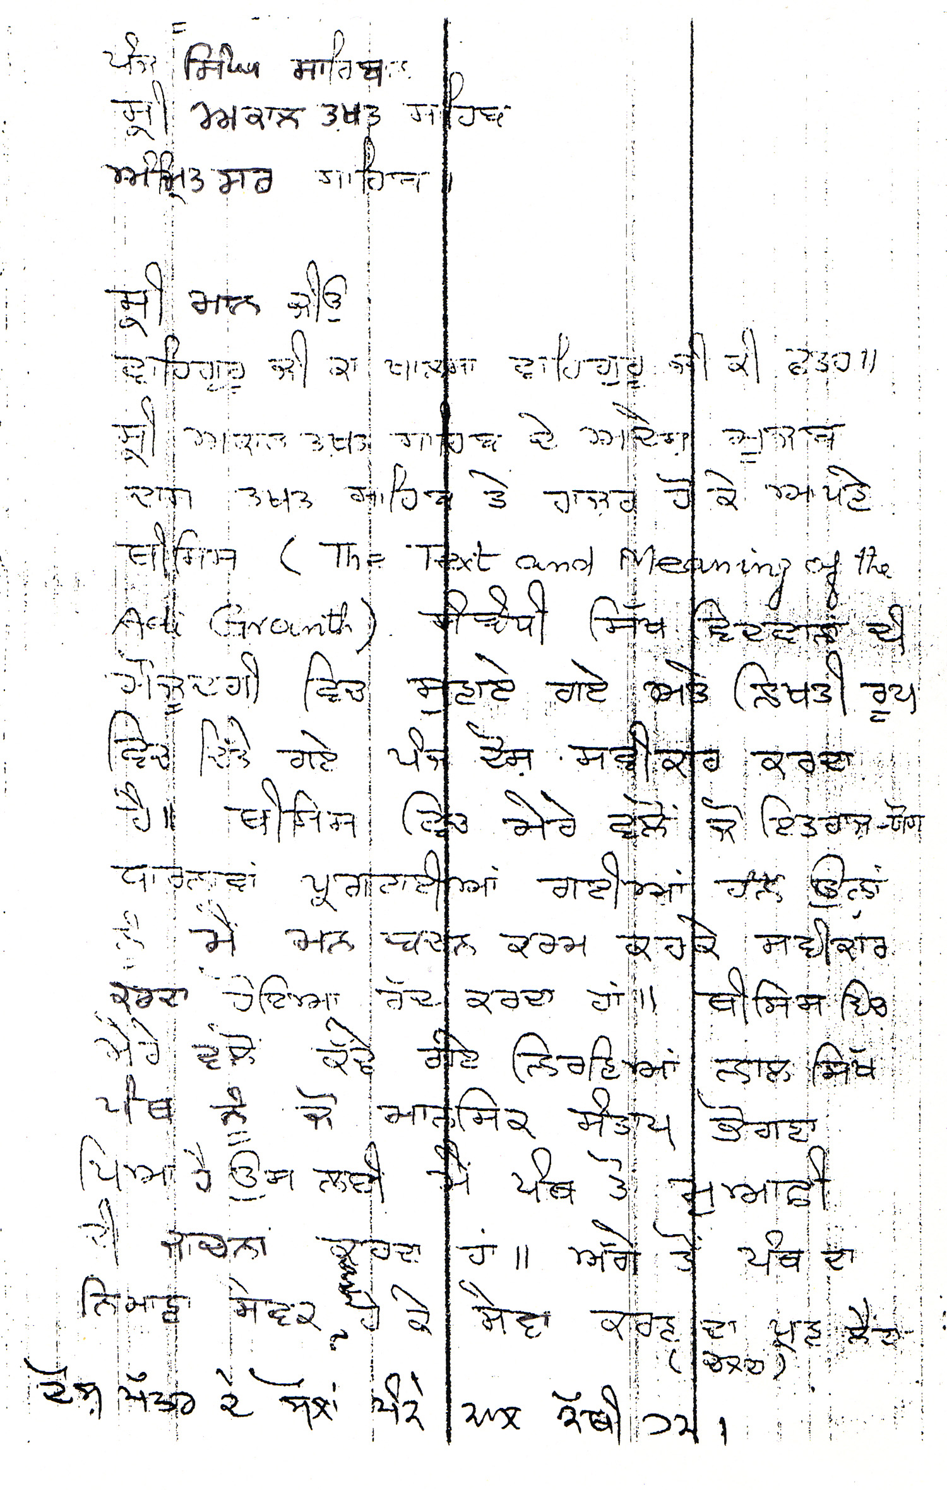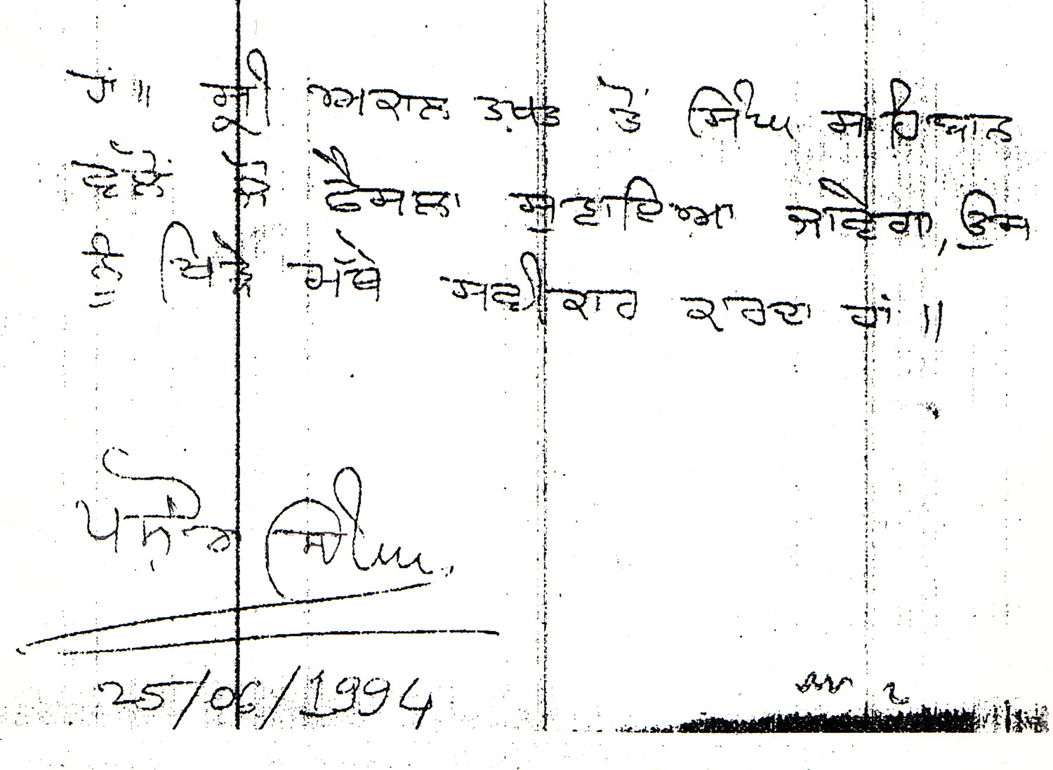
ENGLISH TRANSALTION of CONFESSIONAL STATEMENT OF PASHAURA SINGH in Punjabi in Pashaura Singh’s own handwriting at Sri Akal Takht Amritsar on June 25, 1994
June 25, 1994
The Five Singh Sahiban, Sri Akal Takht Sahib, Amritsar Sahib
Your Holiness

Waheguru ji ka Khalsa; Waheguru ji ki Fateh. Under orders from Sri Akal Takht Sahib, appearing at the Takht Sahib, this humble servant pleads guilty to the five charges in respect of my thesis (The Text and Meaning of the Adi Granth), read out as well as given to me in writing. I hereby reject in thought, word and deed all such objectionable formulations that occur in my thesis. I beg forgiveness of the Panth for whatever hurt the conclusions drawn by me in my thesis have caused to the Panth. In future I pledge to serve the Panth as a humble servant of the Panth. I also willingly accept whatever decision is announced by the Singh Sahiban.

Sd.Pashaura Singh 25/06/1994

CHARGES AGAINST PASHAURA SINGH

Lured by the prospect of getting a Ph.D. degree from the University of Toronto, under the influence of adversaries of the Sikh religion, and purely on the basis of hollow and wild speculation, Pashaura Singh has committed blasphemy, because of his baseless and arbitrary formulations:

Formulations in the Thesis
(In connection with compilation of Sri Guru Granth Sahib) "Then comes a rare manuscript preserved at Guru Nanak Dev University in Amritsar, which may be regarded as one of the many drafts on which Guru Arjun Dev seems to have worked to finally produce the text of the Adi Granth." (Page 24)
"Further it is claimed that the manuscript contains a hymn written in Bhai Buddha's hand on the third decorated page, which may show his involvement in the creation of the scripture. It is quite possible that his descendants may have preserved the manuscript through the process of handing it over to the next generation. Furthermore, folio 1255a of the manuscript contains the death dates of the first five Gurus only, the last of which was written later on by the same scribe." (Thesis pp. 27-28)

Footnote on page 27
"Gurmukh sevaih sada sacha andin sahaj piar. Sada anand gaveh gun sache ardh urdh urdhar. Andar Pritam vasia sacha dhur karam likhia Kartar. Nanak aap milaiya ape kirpa dhar."

The above hymn is recorded on the decorated page 3 of the Manuscript No. 1245 of the Guru Nanak Dev University, which, it is claimed, is the writing of Baba Budha ji.

The attribution of this hymn to Bhai Buddha is based on the family tradition. Seethe note by Harbhajan Singh Harcharan Singh Chawla on the manuscript.

CHARGE NO. 1
The Guru Nanak Dev University MS 1245 of the Mina group which bears on page 1255 the dates of demise of the first five Gurus in the same hand and shade of ink, ipso facto, is clearly a production of the post-Guru Arjun Dev period. To call it the first draft of the sacred recension of Sri Guru Granth Sahib, tantamounts to a mischievous conspiracy to raise baseless doubts on the authenticity of Sri Guru Granth Sahib.

Under the same conspiracy, on the basis of purely arbitrary speculation and guesswork, this manuscript has been linked with the historic personalities very close to the Gurus' house (Bhai Gurdas and Baba Buddha). And these most devout Sikhs, have clandestinely been placed in the same row as the schismatic Minas. This mischief has apparently been done with the intention of exploitation in the future.

Then an effort has been made to establish it as a historic manuscript by linking the Mul Mantra pasted on the fourth folio, with the Ninth Master, on no other basis than the wild imagination of the author.

This is exactly the kind of conspiracy which, since long, an adversary of the Sikh religion, a Christian Missionary, NtcLeod, has been carrying on under the garb of research.

By speaking the above mentioned language of McLeod, the writer has committed an act of treachery or betrayal to his Prophet-Guru and the Sikh world, and has deliberately supplied objectionable material to enemies of Sikhism.

Formulations in the Thesis
"The Guru Nanak Dev University manuscript (GNDU MS 1245) provides an earlier version of the Morning Prayer before its standardization. It begins as:

Satinam karta purkh nirbhau nirvair akal murat ajuni saibhang satgur parsad Jap Mahala 1. Sochai soch na hovai je sochi lakh var.
Chupai chup na hovsi je lai raha liv tar. Bhukhian bhukh na utarai je banha purian bhar.
Sahas sianapan lakh hon ta ik na chalai nal. . Kion sachiara hoiai kion kurai tutai pal.
Hukm rajai chalna Nanak likhia nal.
"A comparative analysis of this text with the standard version of Japujireveals the following important
differences, which illuminate the different stage in the process of its development.

"First the Mul Mantra is given in its earlier form, which is discussed in detail in the preceding section. Second, the title of the composition is mentioned as Japu Mahala 1, ... indicating specifically the authorship of Guru Nanak. In the standard version, however, the symbol mahala 1 is omitted, perhaps consciously to assign divine authorship to the text....." (Page 100-101).

"Third, the most distinctive difference is that the introductory couplet of the Japuji is missing in the earlier text. In the standard version it reads: `The Eternal One, from the beginning, through all time, prersent now, the Everlasting Reality'. (adi sach jugadi sach hai bhi sach Nanak hosi bhi sach). Evidently this shalok was added by Guru Arjun much later..."

CHARGE NO. 2
By accepting Sri Japuji Sahib recorded in the unauthentic Manuscript No. 1245 of the Guru Nanak Dev University, as the original and pre-standardization form, an effort has been made to create confusion over this sacred bani, on the one hand, and on the other hand, it is alleged that Guru Arjun Dev ji tampered with and revised the original form of this bani from several aspects, such as:

"1. The heading of this bani `Mahala 1' was consciously dropped to assign divine authorship to the text.

"2. The inaugural shalok of this bani (adi sach jugad sach hai bhi sach Nanak hosi bhi sach) is authored by Guru Arjun, and this shalok was added to Japuji Sahib much later, when it had been given a final form after revision.
"3. In the process of standardization of this bani linguistic, grammatical and metrical changes were made at several places."

"The long eulogistic description of Guru Amar Das's death may indicate that the scribe was a close associate of the third Guru, possibly Bhai Gurdas, who may have further improved his handwriting by the time he wrote the final draft of the Adi Granth." (Page 28)

"The introductory note written by the shopkeeper in the beginning of the manuscript that `there is abenedictory autograph written in Guru Hargobind's blessed hand on the fourth leaf ..... This is not correct. The examination of the manuscript has revealed that a different piece of paper containing the Mul Mantra written in Guru Tegh Bahadur's hand, was pasted much later on the fourth decorated page." (Page 27)

Some of the salient features of the Guru Nanak Dev University manuscript No. 1245 are:

(A) Mentioned in the Thesis
"1. The manuscript has a total number of 1267 folios. It is in the form of a draft on which Guru Arjun still seemed to be working.
2. It has a different raga sequence, and the index of individual hymns of each raga-section is written separately at the beginning of that section. It begins with Siri raga followed by the usual majh, guari, asa, gujari and vadhans raga. Thereafter, it diverges from the standard pattern and follows its own sequence of dhanasari, jaitsari, sorathi, kalyan, nat-narayan, todi, bairari, tilang, gond bilaval, suhi, bilaval, ramkali, mali- gaura, maru, kedara, tukhari, bhairaun, basant, sarang, malhar, kanara and parbhati raga." (Page 25)
3. There area number of texts in this manuscript that were revised in the final draft. Even Guru Arjun modified his own hymns. For example in the tilang raga on folios 681b - 682c all shabads were revised in the final draft. One of these hymns, was included at the time of giving the final form.

"Finally, the first stanza of the Japuji that appears here has some linguistic variations. Evidently Guru Arjun modified the language of certain words (Jei/je, Utrai/urti, Bana/banna, Sahans/sahas, hon/hohe, kio/kiv), and replaced them with more grammatically and metrically sound construction in order to standardize the text." (Page 103)

"There are numerous such examples throughout the text of Japuji where Guru Arjun refined the language of certain passages and polished the metre.
Note the following examples": GNDU MS 1245 FORM Vin bhane kia nai kari
Mit vich ratan jawahar manak Jio jio hukm tivai tiv kar
Kio sachiara hoie kio kurai tutai pal Bhandai bhao abrit tit dhal
REVISED STANDARD FORM Vin bhane ke nai kari
Mat vich ratan jawahar manak Jiv jiv ham tivai tiv kar
Kiv sachiara hoie kiv kurai tutai pal Bhanda bhao amrit tit dhal

Also, Guru Arjun Dev ji has been accused of making alterations in the revealed message of the Mul Mantra.
Formulations in the Thesis

"The Mul Mantar or the `root formula' with which the Adi Granth opens, is the basic theological statement of the Sikh faith. It consists of different epithets, all of which are traditionally understood as characterizations of Ultimate Reality, or Akal Purakh (`the Timeless Being'). It appears in Volume I of the Goindwal pothis as follows:
Ik Onkar satgur parsad such nam kartar nirbhau nirikar akal murat ajuni sambhau.

Sometimes there is an additional phrase Gur pure ke parsad `by the grace of the Perfect Guru' at the end of this text. But nowhere does this form of the Mul Mantar correspond to the standard version given in the Adi Granth. Evidently this was the form that was current during the period of Guru Amar Das." (Page 93)

"The origin of the major components of the earlier form of the Mul Mantar as given in the Goindval pothis can be traced directly from the works of Guru Nanak." (Page 93)

"Guru Ram Das invoked the divine attributes of the Mul Mantar in one of his compositions. The original verse resembles the text of the Mul Mantar and, similarly, it is free of any metrical or rhyme scheme. It reads as follows:

Jap man nirbhau. Sat sat sada sat. Nirvair akal murat. Ajuni sambhau. Mere man an din dhiae nirankar nirahari. - Sarang Mahala 4 (1201) (Page 95)
"The comparison of this text with the earlier form of the Mul Mantar given above clearly indicates the addition of the word nirvairu (`without enmity'), which Guru Ram Das employs to put emphasis on the divine attribute of benevolence. This may reflect his firm resolve to counteract the situation of hostility in real life, created by the animosity of his rivals, with the spirit of love and friendliness. Thus a new theological dimension is added to the Sikh understanding of Ultimate Reality." (Page 96)

"Although Guru Nanak has also employed the word nirvairu for the Supreme Being in his Ranilcali Dakhni Onkar (AG p. 931), the frequency of its use is greater in the compositions of Guru Ram Das." (Footnote No.14, Page 96)

"Guru Arjun Dev worked over the text of the Mul Mantar in successive drafts to give it its final form. The
Guru Nanak Dev University manuscript, which is an early draft of the Adi Granth, gives the form of the Mul Mantar before its standardization:
Ik onkar satnam kartapurakh nirbhau nirvairu akal murat ajuni saibhang satguru parsad.
In his final version Guru Arjun replaced the phrase Satguru parsadi `by the grace of the True Guru' with gur prasadi, `by the grace of the Guru', presumably to provide a more coherent structure to the text of the Mul Mantar." (Page 96)

Another significant point is that Guru Arjun added the word purakh to the received text of the Mul Mantar. It clearly indicates that by his time the personal aspect of the Supreme Being acquired prominence as compared with Guru Nanak's emphasis on the formless (nirankar) nature of Ultimate Reality." (Page 96- 97)

"This (addition of the word purakh) may provide an adequate explanation of the subsequent development that took place in Sikh doctrine as well as within the Panth since the days of Guru Nanak. This will, however, challenge the traditional understanding of the Mul Mantar as being created in its present form by Guru Nanak himself." (Page 97)

CHARGE NO. 3
There are pothis with apocryphal hymns composed by the Minas under the name `Nanak'. The author himself doubts their authenticity (indication of which has been given on page 9 of his thesis). But he takes them as basis of the Adi Bir, and accepts the so-called Mul Mantar recorded therein (which is different from the Mul Mantar in the authentic bir), as real and original, and thus levels against Guru Ram Das ji and Guru Arjun Dev ji, accusations of making alterations in it.

"One of these hymns, numbering 5 in folio 682a (Jo gur disai Sikhra niv niv lagon pae) is repeated in the suhi node in folio 729b with the addition of the first line appearing at the end as well. A marginal note appears in folio 682a to this effect saying that `it is taken to the suhi mode' (Suhi vich lia hai). This hymn was further revised in the final draft with the addition of jiu at the end of each line to make it more musical." (Page 25- 26)

"It does not contain the bhagat-bani....." (Page 26)

"The panegyrics by the bards (Bhattan de savayye) in praise of the Gurus are still in their earlier short form. By the time this manuscript was written some of them had not yet appeared in the court of the Guru. Even the var by Satta and Balwand in the ramkali mode is not to be found in this manuscript." (Page 26)

"There exist some specimens of such hymns in an early manuscript. See Bhai Gurdas Library, Rare Books Section, GNDU, MS No. 1245, ff, lOlb-1035. A fifteen verse composition Sri Ragu Maha13 Chhant is attributed to Guru Amar Das, but it is not included in the standard version of the Adi Granth. It may have originated from the circles of schismatic groups." (Page 9, Footnote 32)

Special Comments:
1. In this manuscript variations from the authentic bir of Guru Granth Sahib, abound, in respect of vowels, spellings, shabads, etc., which are common in Mina literature.
2. This manuscript does not bear any date or year of scribing, nor does it have any historical significance. Before its purchase by the Guru Nanak Dev University, the manuscript has never been mentioned by any historian or scholar of birs.

Formulations in the Thesis
"There is some evidence that Guru Gobind Singh made an attempt to standardize the text of the Adi Granth and thus to correct the problem of the circulation of three different versions of it during his period." (Page 60/80)
"It is quite possible that Maharaja Ranjit Singh appointed a council of prominent Sikh scholars to prepare an authorized version of the Adi Granth." (Page 84)
"The new version was, in fact, a revival of the earlier Damdama version, compiled during the period of Guru Gobind Singh in the late seventeenth century, which went out of circulation due to the period of turmoil during the eighteenth century. However, in this version the place of jaijavanti raga and the sequence of the shaloks of the ninth Guru were fixed. In certain instances, the language of the shaloks was modified. The solitary couplet that was attributed to the tenth Guru in early manuscripts, lost its authorship and became a part of Guru Tegh Bahadur's shaloks. This may have been intentionally done to keep Guru Gobind Singh's authorship limited to the bani in the Dasam Granth. It may also reflect the contemporary debate over the issue of Sikh identity, that is, whether one follows the teachings of Guru Nanak and his successors contained in the Adi Granth, or one joins the Khalsa of Guru Gobind Singh." (Page 85-86)
CHARGE NO. 4
Both according to history and tradition, Guru Gobind Singh got the bir of Sri Guru Granth Sahib prepared by Bhai Mani Singh at Damdama Sahib, in which the bani of Guru Tegh Bahadur was also included. This came to be known as Damdami Shakh. Why the Tenth Lord did not include his own bani in it, the Guru alone knows.

Then the author completely ignores the above fact, and without quoting any historical reference and under some conspiracy indulges in wild conjectures: "It is quite possible that Maharaja Ranjit Singh appointed a council of prominent Sikh scholars to prepare an authorised version of the Adi Granth." (Page 84)

In this new version "the solitary couplet that was attributed to the Tenth Guru, in early manuscripts lost its authorship and became a part of Guru Tegh Bahadur's shaloks. This may have been intentionally done to keep Guru Gobind Singh's authority limited to the bani in the Dasam Granth. It may also reflect the contemporary debate over the issue of Sikh identity, that is, whether one follows the teachings of Guru Nanak and his successors contained in the Adi Granth, of one joins the Khalsa of Guru Gobind Singh."

This writing reflects a mischievous design to divide the Sikh Panth into two classes, vi'z., the followers of the first nine patshahis, and the Khalsa of Guru Gobind Singh, as also to divide the Gurus into different categories.

3. As far as the note given by M/S Harbhajan Singh Harcharan Singh Chawla, is concerned, the firm was summoned at the Akal Takht Sahib for additional information. A copy of the statement given by them on 5.5.93 is enclosed. They made it clear that "they procured this copy in 1979-80 during their trip to Ganga Nagar district of Rajasthan from a waste paper dealer, which they later sold to the Guru Nanak Dev University. The note pasted on the manuscript by them is not based on any research investigations. It only records what was narrated by one Bhai Karnail Singh, a granthi of Amritsar."

Evidently, the note on the manuscript was a master stroke of salesmanship to extract maximum price. It seems that since this note fitted into the designs of McLeod, he instructed his willing tool, Pashaura Singh, to adopt it as a basis of his thesis.

CHARGE NO. 5
At several places in the thesis clumsy efforts have been made to create confusion over Sikh doctrines, Sikh history and authenticity of Gurbani, and thus to erode the foundations of the Sikh religion. The deliberate misrepresentations made under the garb of research, point to a deep-rooted conspiracy.

Formulations in the Thesis
1. "There is enough evidence that a number of hymns of the Bhagats were included in the Kartarpur manuscript after it was bound. For instance, Ratndas's hymn `Begampura shahr ko nao' in the gauri raga in folio 278/2 and dhanasari hymn `Gopal tera arta' in the dhanasari mode in folio 519/2, were added much later on each page by keeping extended margin on the left side of the Kartarpur manuscript. Their inclusion in the scripture reflects a situation wherein the followers of these Bhagats (the Jats and the cobblers) were attracted into the Sikh fold in large numbers." (Page 26)
2. "In order to stress the theme of the unity of guruship, Guru Arjun intentionally incorporated in certain instances his own shaloks in the works of Guru Nanak." (Page 145)
"The addition of Guru Arjun's shaloks at the beginning of Guru Nanak's hymn further highlights the issue of doctrinal consistency in guruship. It serves to underline Guru Arjun's claim that he carries the spiritual authority of Guru Nanak." (Page 147)
3. Regarding the variations in the concluding shaloks in the standard form those in the GNDU manuscript

1245, resort has been taken to different kinds of conjectures:
"There are, however, scholars" (McLeod) "who regard Guru Angad as its real author." (Page 105)

"Its addition to the Morning Prayer was perhaps intentionally done to stress the continuity and unity of guruship." (Page 106)

"Guru Nanak may have initiated his successor, Bhai Lehna, into the poetic skill of verse composition in the literary form of a shalok, and this training may have been a 'part of his designation to the office of guruship. The two Gurus may have worked together on the text of the epilogue of the Japuji, and accordingly both may be regarded as its joint authors." (Page 107-8)

"Here it is important to note that the last stanza is Guru Arjun's contribution of Guru Amar Das's composition, which he intentionally added to the original text at the time of its standardization, thereby reinforcing the recurring theme of the unity of guruship." (Page 111)

After accepting charges at Sri Akal Takhat, he did not refrain from his blasphemous views and published a book "The Guru Granth Sahib Cannon Meaning and Authority" in 2000. On examination of this book one can find that he is still harping on the issues for which the Akal Takht summoned him in 1994. For example he associates Guru Arjan, Bhai Gurdas ji and Baba Budda with a manuscript, which is full of Kachi Bani (pp., 23, 30, 43, 46). He sticks to his old notion that the Mul-Mantar that we have presently at the beginning of Guru Granth Sahib, is not original but has been revised many times (pp., 84-90). He alleges that Guru Arjan has tinkered with the Japji of Guru Nanak to produce the final text (pp., 90-96). He reiterates the same old formula that Guru Arjan has-been revised his own hyms in the final text (pp., 106-114). Unfortunately all these formulations are based on the questionable evidence. It hits at the revealed character of Bani. He has once again challenged the authenticity and originality of the Bani that is highly uncalled for.
The Coalition of Gurudwaras of California took serious notice of the above and held two meetings of Sikh Gurudwaras and institutions on May 22nd, 2005 at Riverside and June 12th, 2005 at Fresno, and resolved to send an urgent request to Jathedar Sri Akal Takhat to call for immediate action per Sikh Rehat Maryada.

Raminder Singh Sekhon and Dr. Baljit Singh Sahi
Spokespersons for Coalition of Gurdwaras of California

The following Sikh Gurdwaras and Sikh Institutions in Southern California who participated May 22nd, 2004 meeting on the above issue from:

Gurudwara Riverside, 7940 Mission Blvd. Riverside, CA. 92509
Gurudwara Alhambra, 101 south Chapel Ave. Alhambra, CA 90801
Gurudwara Vermont, 1966, Vermont Ave. Los Angles, CA. 90027
Gurudwara Lankershiem, 7640, North Lankershim Blvd. North Hollywood, CA 91607
Gurudwara Buena Park, 7122 Orangethorpe Ave, Buena Park, CA 90620
Sikh Center of Orange County, 2530 Warner Ave. Santa Ana, CA.92704
Sikh Educational & Welfare Association, 20001 E.Walnut Drive South, Walnut CA
Guru Ram Das Ashram, 1800 Robertson Blvd, #929, Los Angeles, CA 90035
Sikh center of Southern California, 625 South Eremland drive, West Covina, CA 91723
Gurudwara of Ventura County
Gurudwaras of Bakersfield

The following members of the Sikh community represented the Aforementioned Gurudwaras and institutions:

S. Rashpal Singh, S. Jagdev S. Atwal, S. Lakbir Singh, S. Sohan Singh Gill, S. Sikander Singh, S. Gurdev Singh Virk, S. Pritam Singh, S. Amarjit Singh, S. Akwinder Singh, S. Harinder Singh, S. Joginder Singh Sandhu, S. Lehmber Singh, Dr. D. S. Gill, S. Tarlok Singh Sandhu, Dr. Jasbir Singh Mann, S. Parmjit Singh, S. Jhalman Singh, S. Ujjagar Uppal, S. Gurbachan Sandhu, S. Makhan Singh Sandhu, S. Gurmeet Singh Brar, S. Bharpur Singh Dhanau, S. Atma Singh Kainth, Dr. Piara Singh, S. Harjit Singh, S. Gurpreet Singh Khakh, S. Santokh Singh Sahi, S. Jasminder Singh, S. Bahadur Singh, S. Kirtan Singh Khalsa, S. Gagan Singh, Dr. Jagdev Singh Dhaliwal, S. Bharpur Singh Takhar, S. Brinderjit Singh Dhillon, S. Sarbjit Singh Sandhu, S. Baljit Singh Bathh, S. Jasmer Singh Randhawa, S. Bahal Singh Brar, S. Sukhminder Singh, Inderpal Singh Ahluwalia, S. Ronak Singh Bhullar, S. Dalbir Singh Sanghera, S. Surinder Singh Sidhu, S. Ranjit Singh, S. Raminder Singh Sekhon, Surjit Singh Malhi, and Dr. Baljeet Singh Sahi.

On June 12th, 2005 at Fresno, the following members from Northern and Central California represented the following Gurdwaras and institutions:

Balwant S. Virk - Sacramento Sikh Society Gurdwara at Bradshaw Rd, CA
Jaswant S. Hothi – Sikh Gurdwara Sahib, San Jose, CA
Balbir Singh – Gurdwara Sahib, Fremont, CA
Manjit Singh – Gurdwara Sahib, Stockton, CA
Daljit Singh Khalsa – Gurdwara Sahib, Stein Rd, Bakersfield, CA
Resham Singh – Guru Angad Darbar, Bakersfield, CA
Pavittar Singh – Gurdwara Sahib, Terra Buena, Yuba City, CA
Balraj Singh – Gurdwara Sahib, Terra Buena, Yuba City, CA
Balbir S. Dhillon – Gurdwara Sahib, West Sacramento, CA
Jasvinder Singh – Sikh Youth Of America, Union City, CA
Harjot S. Khalsa – Amritsar Times (Newspaper), San Jose, CA
Ranjit S. Tut - Radio Geet Sangeet, Watsonville, CA
Bhupinder Singh – Kalgidhar Gurdwara Sahib, Selma, CA
Dr. Pritpal Singh – American Gurdwara Parbhandik Committee, CA
Gurpreet S. Sandhu – Quami Ekta (Newspaper), CA
Mohinder S. Grewal – Sikh Council of Central California, Fresno, CA
Amrik S. Virk – Sikh Center of the Pacific Coast, Selma, CA
Bhajan S. Bhinder – Sikh American Republican Party, CA
Others; Bickey Singh-President, Sikh Center of Orange county,Ca

